首都经济贸易大学2026年硕士研究生招生考试
《翻译硕士（英语）》初试大纲
科目代码：211

说明：
1.本科目考试时不得使用计算器。
2.请考生随时关注我校研究生院网站招生动态栏目（网址https://yjs.cueb.edu.cn/zsks/zsdt/index.htm），如有大纲更新或变动，均以官方网站的最近通知为准。

第一部分 考试说明
- 考试目的
《翻译硕士英语》作为全日制翻译硕士专业学位(MTI)入学考试的外国语考试，其目的是考察考生是否具备进行 MTI 学习所要求的外语水平。本考试是一种测试应试者单项和综合语言能力的标准参照性水平考试。考试范围包括 MTI 考生应具备的英语词汇量、语法知识以及英语阅读与写作等方面的技能。

二、考试范围
本考试采取客观试题与主观试题相结合，单项技能测试与综合技能测试相结合的方法。各项试题的分布情况见“考试内容一览表”。

三、考试基本要求
1. 具有良好的英语基本功，认知词汇量在 10,000 以上，掌握 6,000 个以上的积极词汇，即能正确而熟练地运用常用词汇及其常用搭配。
2. 能熟练掌握正确的英语语法、结构、修辞等语言规范知识。
3．具有较强的阅读理解能力和英语写作能力。

四、考试形式与试卷结构
1. 答卷方式：闭卷，笔试
2. 答题时间：预计180分钟，以我校实际招生简章公布为准。
3. 题型及分值：本科目总分预计为100分，以我校实际招生简章公布为准。题型预计包括词汇语法、阅读理解、英语写作等。仅供参考，实际命题可能略有出入。
4. 各部分内容考查比例
词语语法：10%；阅读理解40%；英语写作50%

五、参考书目
无

六、需说明的问题
无

第二部分 考试内容

一、词汇语法
1. 要求
1）词汇量要求：
考生的认知词汇量应在 10,000 以上，其中积极词汇量为 6,000 以上，即能正确而熟练地运用常用词汇及其常用搭配。
2）语法要求
考生能正确运用英语语法、结构、修辞等语言规范知识。
2. 题型
单项选择题

二、阅读理解
1. 要求
1）能读懂常见外刊上的专题文章、历史传记及文学作品等各种文体的文章， 既能理解其主旨和大意，又能分辨出其中的事实与细节，并能理解其中的观点和隐含意义。
2）能根据阅读时间要求调整自己的阅读速度。
2. 题型
1)单项选择题（包括信息事实性阅读题和观点评判性阅读题）
2)结构分析题（分析作者观点、文章结构、段落逻辑等）

三、英语写作
1. 要求
本部分题材广泛，体裁多样，选材体现时代性、实用性； 重点考查通过阅读获取信息和理解观点的能力；对阅读速度有一定要求。考生能根据所给题目及要求撰写一篇150词以上200词以下的图表作文和一篇400词左右的记叙文、说明文或议论文。两篇作文要求语言通顺，用词得体，结构合理，文体恰当。
2. 题型
命题作文
考试内容一览表
序号 | 考试内容 | 题型 | 分值 | 时间(分钟)
1 | 词汇语法 | 单项选择 | 10 | 20
2 | 阅读理解 | 1) 单项选择  2) 文章结构分析 | 40 | 80
3 | 英语写作 | 1）小作文（命题作文）  2）大作文（命题作文） | 50 | 80
共计 |  |  | 100 | 180

第三部分 题型示例

考生请注意：题型示例仅供参考，每类题型仅提供1道例题，实际考试试题数量与本部分不一定相同。
Part I Vocabulary and Structure
Directions: There are 10 incomplete sentences in this part. For each sentence, there are four choices marked A, B, C and D. Choose the ONE answer that best completes the sentence and write the corresponding letter on the ANSWER SHEET.

- The salesman was accused of ______ the customer about the condition of the car.
A. conceiving
B. perceiving
C. retrieving
D. deceiving

Part II Reading Comprehension
Section A
Multiple-Choice Questions
Passage One
Historians of the American Civil War find themselves in the same unenviable position as Shakespeare scholars: so thoroughly have their fields of study been explored that finding a nearly virgin comer is all but impossible. But Don Doyle has broken new ground in enlightening and compellingly written book, The Cause of All Nations. More than any previous study, it tells the story of how America’s Civil War was perceived, debated and reacted to abroad, and how that reaction shaped the course of the war at home.
At the war’s outset, however, things were not so simple. Southern diplomats framed their struggle in accordance with liberal principles of self-determination. They judged the conflict, Mr. Doyle notes, to be “one arising naturally between industrial and agricultural societies, not freedom and slavery as the North believed.” The North’s response, meanwhile, was uncompromising, legalistic and violent. America’s secretary of state threatened to “wrap the whole world in flames” promising total war on any state that dared aid the South. Most histories of the Civil War turn inward at the end and examine the war’s consequences and legacy for America. Mr. Doyle turns outward to show how important America’s Civil War was to the rest of the world: liberty and democracy defeated slavery and the landed gentry. The Union’s victory had wider impacts. In Spain, Queen Isabella, fearing American naval power, ended the attempted re-colonization of Santo Domingo. Ulysses Grant, a civil-war general turned his military attention to Mexico, where Napoleon III had installed an Austrian, Maximilian, as emperor. When the threat of an alliance between France and the South was smashed, Napoleon withdrew his support and in 1867 Maximilian was executed by Mexican troops. Across the ocean, Britain’s republicans marched to victory that same year. Democracy had not just survived, but flourished.
After Lincoln’s death, a French newspaper wrote that he “represented the cause of democracy in the largest and the most universal understanding of the word. That cause is our cause, as much as it is that of the United States.” In honor of the Union’s victory, a French artist crafted a statue out of copper sheeting, a figure representing freedom, tall and proud, holding a torch high. The Statue of Liberty stands today in New York harbor, the copper now green with age, her gaze fixed across the Atlantic on Europe.

1. Shakespeare is mentioned in the first paragraph to illustrate that_______.
A. historians of the Civil War should learn from Shakespeare
B. new discoveries are easy concerning the cause of the Civil War
C. the Civil War has been studied as extensively as possible
D. the Civil War and Shakespeare’s works are known worldwide

2. The book entitled The Cause of All Nations is focused on________.
A. the impact of the Civil War on other countries
B. factors that caused the outbreak of the Civil War
C. the political difference between the North and South
D. the consequences of the Civil War for America

3. The North regarded the Civil War as a war________.
A. between industrial and agricultural states
B. between slaves and slave-owners
C. between freedom and slavery
D. between the government and people

4. Paragraph Four is mainly concerned with________.
A. the effect of incidents abroad on the Civil War
B. contributions of Europeans to the Union’s victory
C. numerous conflicts between European countries
D. effects of the Union’s victory on other countries

5. The passage is probably a ___________.
A. personal letter
B. research paper
C. book review
D. fairy tale
Section B
Text Structure Analysis

Nature or Nurture
① Most developmental scientists now agree that both nature (genetics) and nurture (environment) are essential for the normal development of perception. However, there is still much dispute about the extent to which either nature or nurture is the more important factor. Points of view on this issue are more than just philosophical musings, they affect the kinds of experiments that are undertaken. I argue here that classifying particular aspects of perceptual development as either innate or learned presents us with an overly passive view in which either genes or environment imposes structure on the developing brain. In contrast, I suggest that perceptual development is better characterized as an activity-dependent process involving complex and subtle interactions at many levels.
② To begin to illustrate my point, let’s consider some recent neurobiological work on the prenatal (before-birth) development of the brain in rodents. Neurons are specialized cells that transmit impulses or messages to other neurons, glands, and muscles. The neurons studied in these experiments are those involved in binocular vision. Experiments show that the prenatal tuning (training) of these neurons arises through their response to internally generated waves of electrical activity. In other words, the response properties of these visual neurons are shaped by a “virtual environment” generated by cells elsewhere in the brain and eye. Although the term “innate” can be stretched to cover this example of development, we could equally well describe this process as the cells “learning” from the input provided. Further, after birth the same neurons continue to be tuned in the same way, except that now their input also reflects the structure of the world outside. When we examine development in detail, it becomes harder to argue, as some theorists do, that “innate knowledge” is fundamentally different from learning.
③ Another example of the role of activity-dependent processes in perceptual development comes from the ability to detect and recognize faces. Because regions of the human brain are specialized for processing faces, some researchers have argued that this ability is innate. However, experiments with infants reveal a more complex story. The tendency for newborns to look more toward faces turns out to be based on a very primitive system that is triggered by a stimulus as simple as three high-contrast blobs in the approximate locations of the eyes and mouth. This simple bias is sufficient to ensure that newborns look much more at faces than at other objects and patterns over the first weeks of life. One consequence of this is that developing circuits on the visual recognition pathway of the brain get more input related to faces and thus are shaped by experience with this special type of visual stimulus. We can now study this process by using new brain-imaging methods. Such studies have shown that the brains of young infants show less-localized and less-specialized processing of faces than do the brains of adults. It is not until they are one year old that infants show the same patterns of brain specialization for processing faces as do adults, by which time they have had as much as a thousand hours of exposure to human faces.
④ Another example comes from the study of infants’ eye movements to visual targets. Although newborns are capable of some primitive reflexive eye movements, only much later in the first year can they make most of the kinds of complex and accurate eye movements seen in adults. One view is that the very limited ability present in newborns is just sufficient to allow them to practice and develop new brain circuits for the more complex integration of visual and motor information necessary for adult eye movements. Once again, it appears that infants actively contribute to their own subsequent development.
⑤ These considerations should make us skeptical about the many claims that are made for innate perceptual abilities based on experiments with babies of four months and older. In fact, when the same experiments were done with younger infants, quite different results have often been obtained, suggesting dramatic changes in perceptual abilities over the first few weeks and months after birth.
⑥ Infants are not passively shaped by either their genes or their environment. Rather, perceptual development is an activity-dependent process in which, during postnatal life, the infant plays an active role in generating the experience it needs for subsequent development.

Please briefly analyze the structure of this text (80-100 words).
Part Ⅲ Writings (50 points)
Writing A (20 points)

The graph below shows the number of shops that closed and the number of new shops that opened in one country between 2011 and 2018. Summarize the information by selecting and reporting the main features, and make comparisons where relevant.
Write at least 150 words.
Number of shop closures and openings 2011-2018

Closures Openings
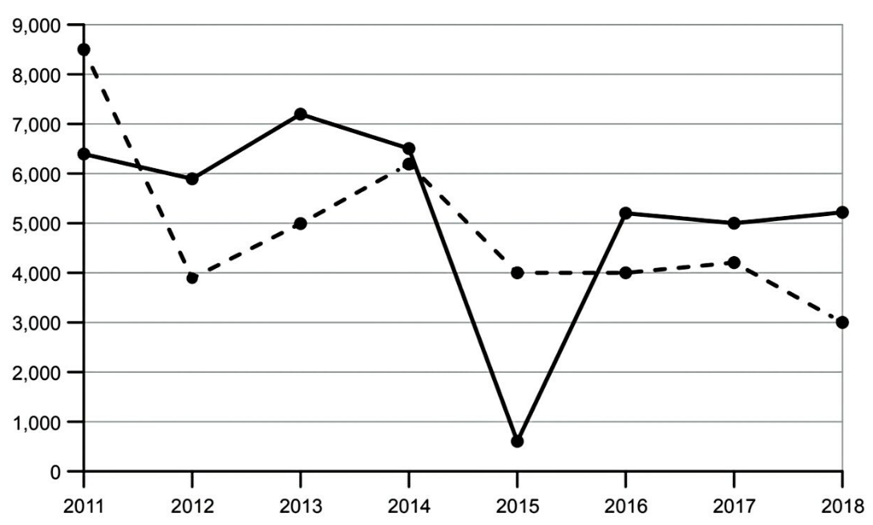

Writing B (30 points)

Directions: For this part, you are going to read the following passage and write a composition of about 400 WORDS. Remember to create a TITLE for your composition.
According to a survey report, over 40% of female respondents (受访女性) in China hope that their ideal partner’s (理想伴侣) occupation is a public servant or government employee (公务员), while 38.3% of male respondents hope their partner’s occupation is a teacher.
What do you think of the two choices? What social realities are reflected?

