Course: Advanced Topics in Econometrics 高级计量经济学
Instructor: Prof. Qi Li
Assistant: Dr. Kunpeng Li

Course Description:
This course will mainly focus on nonparametric/semiparametric methods and their applications in economics. We will show that nonparametric/semiparametric methods can help us solve problems that can be difficulty to handle using conventional parametric approach. Nonparametric methods also have its limitations. We will discuss this as well. Nonparametric methods is a complement, rather than substitute, to the popular parametric methods.

We will mainly discuss the nonparametric kernel method with independent data. Other nonparametric methods such as series (spline) method will be briefly discussed. We show that all asymptotic analysis can be extended to cover the weakly dependent data case. Nonparametric estimation with non-stationary data will also be covered (if time permits).

We will also discuss a few useful econometric methods (parametric methods) in estimating treatment effects, and in analyzing nonstationary data.

At the beginning of the course we will review linear regression models with independent data. We first study the finite sample property of the least squares estimator under some strong assumptions. Then we show that these strong assumptions can be removed provided that one has a relative large sample size. Because when sample size is large, one can reply on laws of large numbers and central limit theorems to derive the distribution of the least squares estimator without imposing strong assumptions. We then discuss some simple regression models with time

series data. After that we will move to study nonparametric econometric models. We will also cover many applications of nonparametric/semiparametric methods to economics problems.

Text book: “Nonparametric Econometrics: Theory and Practice”, by Li, Q. and Racine, J. 2006. Princeton University Press.

Bio for Instructor:
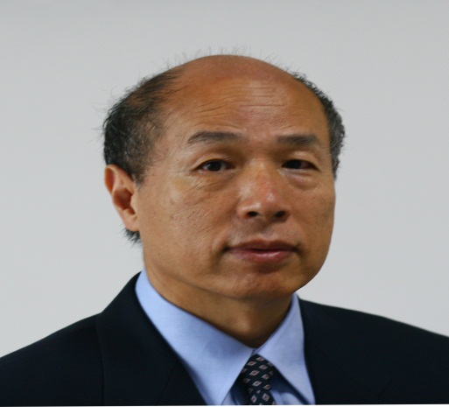

Qi Li is a professor at the International School of Economics & Management at the Capital University of Business and Economics, and the Hugh Roy Cullen Professor in Liberal Arts at Texas A&M University. Professor Li serves as an associate editor of six international journals including Journal of Econometrics, Economics Letters and Econometric Reviews. He also served in the past as a co-editor of (United Kingdom Royal Economic Society's) Econometrics Journal, and an associated for Econometric Theory and Journal of Nonparametric Statistics.
Professor Qi Li's main research field is econometrics, including nonparametric econometrics, panel data method and non-stationary data analysis. Professor Li has published n 120 papers in international economics and statistical journals, including Econometrica, American Economic Reviews, Journal of Econometrics, Journal of Economic Theory, Review of Economics and Statistics, International Economic Reviews, Games and Economic Behavior, Journal of Business and Economic Statistics, Econometric Theory, Journal of American Statistical Association and Annals of Statistics. He also published a book (co-authored with Jeffrey S. Racine) entitled ``Nonparametric Econometrics: Theory and Practice'' by the Princeton University Press.
Course: Organizational Behavior组织行为学
Instructor: Prof. Johan Coetsee
Assistant: Dr. Wenchuan Liu

Course Description:
Organisational behaviour is the study of individuals and groups within an organisational context, and the study of internal processes and practices as they affect individuals and groups. The field of organisational behaviour borrows many concepts and methods form the behavioural and social sciences, such as psychology, sociology, political science and anthropology. As a result, issues and topics touching on many academic disciplines may become the subject of study in the field of organisational behaviour. The course gradually broadens the level of perspective, starting out with an individual level perspective on motivation, attitudes and stress, proceeding to a group level perspective on group dynamics, teams and leadership, power and politics and culminating in the organisational level perspective on culture and change. The aims of the course are:
▪ Top provide students with a broad and critical understanding of current OB theory and research;
▪ To provide insights into participants’ own behaviour, motivations, experience of work groups, teams and organisational environments
▪ Through cases and classroom experiences, to explore how insight and knowledge can be translated into business problem-solving
▪ To prepare students for future roles in which they need to work with individuals and groups in organisations.
The course consists of the following 8 Topics:
1. Fundamental concepts and overview of organisational behaviour
2. Work motivation, attitudes and stress
3. Groups and group dynamics
4. Working in teams
5. The art and practice of leadership
6. Power and politics in the workplace
7. Organisational culture
8. Leading change
The purpose of this course is not just to teach you about the theory behind how organizations and individuals mutually influence one another, but also to help you develop a sophisticated understanding of the motivations that drive people’s behaviour in real organisations, and the skills and confidence to promote your ideas and views within an organisation in the ‘real world’. To accomplish this objective, we will draw on a variety of teaching methods, including lectures, class and group discussion, and case studies. This format means that it is essential that you come to class prepared for discussions, having read and thought about the materials, and willing to participate.

Bio for Instructor:

Johan is a faculty member of Newcastle Business School at Northumbria University, United Kingdom. He is an aaccomplished professional with 20 years international experience (South Africa, Ireland, United Kingdom) working in academia and consulting to diverse, global organisations in the areas of Leadership, Organisational behaviour, and Human Resource Management. He was awarded a Doctorate in Human Resource Development in 1998 and also holds the following qualifications: Masters of Business Administration, Masters of Commerce degree, B Com degree (Hons). Currently, he is involved in executive education, undergraduate and post-graduate teaching. Before joining NBS, Johan held a number of senior positions in academia and industry. His background is in chemical, manufacturing, banking and organizational development. His main academic interests are in Change management and creating organizational readiness for change. In particular, this professional expertise has been put into practice by designing and delivering executive and master’s level programmes for senior and executive managers from a range of organisations.
Course: Advanced Macroeconomics高级宏观经济学
Instructor: Prof. David Prescott
Assistant: Dr. Penny Xiaofeng Li

Course Description:
This course is intended for senior undergraduates in economics and business. Graduate students at the masters level may also choose to attend. Students who intend to register for this course will have completed a macroeconomics course at the intermediate level as well as economic statistics and an introduction to econometrics.
Part I will focus on growth theory. The material will be primarily based on the text by David Romer: Advanced Macroeconomics. The Solow model in which the rate of saving is exogenous will be presented and discussed. Key concepts include the nature of the steady state (the balanced growth path), the golden rule capital stock, and the speed of adjustment to the steady state path. Next, the behaviour of firms and households is developed in more detail. Specifically, households maximize the present value of utility by choosing an optimal consumption path. Consequently the saving rate becomes endogenous. The model has testable implications which will be discussed. Diamond’s model of overlapping generations allows for the possibility of dynamic inefficiency. Finally, the course will provide an introduction to endogenous growth theory.
Part II will examine that determine output and prices in the short run. The role of nominal rigidities in explaining deviations from the full-employment level of output will be examined. Topics will also include monetary policy and inflation. The causes of the “great recession” particularly in western economies (the recession that began early in 2008) and the policy dilemmas that this has presented.
During this course, students will complete problem assignments, write a short report based on some empirical investigation and write a final examination.

Bio for Instructor:

David Prescott is Professor of Economics in the Department of Economics and Finance at the University of Guelph, Canada. He received a B.A.degree in Economics from Durham University, United Kingdom, an M.A. degree from the University of Warwick, United Kingdom, and a Ph.D. degree from Queen's University, Canada. His teaching and research interests are in applied econometrics and macroeconomics. He has been awarded the University of Guelph’s most prestigious teaching award: The John Bell Award and has been nominated for the national 3M teaching fellowship.
His research has been published in journals including Journal of Labor Economics, Applied Economics, American Journal of Agricultural Economics, Canadian Journal of Economics, and the Canadian Journal of Forestry. With David Wilton (University of Waterloo) he co-authored a text book on macroeconomics: Macroeconomics, Theory and Policy in Canada (Addison Wesley, 3 editions) His administrative positions include Assistant Dean for teaching and information technology, College of Social Science and Associate Dean Academic, College and Management and Economics.
Course: Intermediate Data Analysis: A Problem-Oriented Approach中间数据分析
Instructor: Professor Guo Yi
Assistant:

Course Description:
In this course, four generic problems will be discussed, including repeated measures analysis, ordinary least squares regression, logistic regression analysis and time-to-event analysis. The three latter problems will be illustrated with a real data set and three reports will be produced that simulate writing a paper for publication. Such reports will rely heavily on use of statistical software STATA and will follow the usual outline for article publication, namely, introduction and motivation, materials and methods and results of the study, discussion and conclusions.
This course is open for first year graduate students, and junior or senior undergraduate students with some basic knowledge in statistics.
Bio for Instructor:
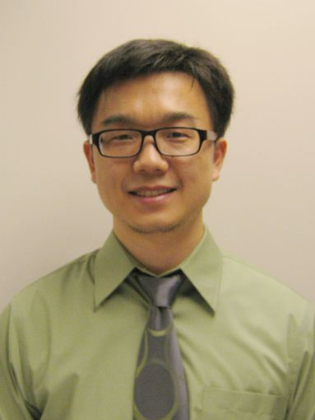
Guo Yi, PhD is an Assistant Professor in Department of Health Outcomes and Policy in College of Medicine at University of Florida. Professor Guo graduated from Division of Biostatistics, College of Public Health at the Ohio State University in 2010. His research areas include power and sample size analysis for multilevel and longitudinal data, linear models, cancer registry data analysis, etc. He has published more than ten original research articles in high impact peer-reviewed scientific journals. Professor Guo is an investigator on three major research grants from National Institute of Health (NIH); the total amount of the grants is close to 10,000,000 dollars. Professor Guo is also the director of the Statistics and Data Coordinating Center of NIH’s Center for Research to Reduce Disparities in Oral Health.

